Community Impact Captain
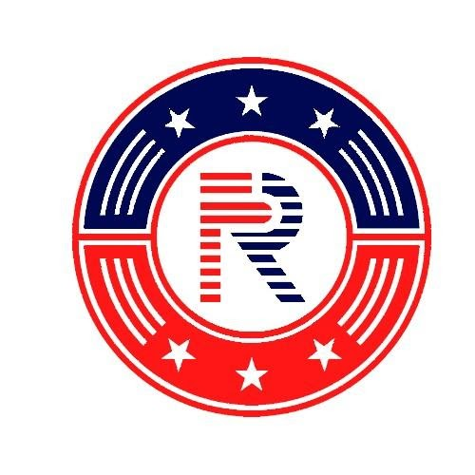
Community Impact Captain: This position is simply about relationship building in the community to increase the impact we have as we set out to leave a positive mark.

Responsibilities:
1. Cultivating partnerships within your local communities. Plan and Community Impact Projects.
- Who can we partner with for our “anchor programs”, big unity projects, family friendly program, and other areas your unit sees fit.
- Maintain relationships with veteran organizations in the area (Team RWB, Team Rubicon, VA, The Mission Continues, VFW, American Legion, USO…)
- Reach out to local leaders (City government, Parks and Rec, School Student Councils, Coaches, Chamber of Commerce)
- Reach out to local organizations (Food Bank, YMCA, Big Brother/Big Sister, United Way, Churches)
- Our goal is to have a monthly impact Project
2. Reinforce the unit leaders lead
a. Genuinely welcome new members. The more people who welcome a new member, they more welcomed they
are going to feel. Work with your unit leader to create a one-two punch welcoming new people.
b. Serve by example. You are a leader in your unit, members are looking up to you. They will benefit greatly from a
strong community impact captain who connects them to meaning service and community opportunities.
c. Care for the people in your unit by connecting them to their community and people in their community. Keep
reaching out to them offering them ways to be involved.
3. Maintain the community engagement records.
a. This will be an excel sheet on google drive for you to add contact information for each of your partnerships.
Maintaining this document will allow for smooth transitions, increased community involvement and greater
organization within Freedom’s Ring USA.
4. Engage in Leadership Training
a. While we are young, these leaders will go through the same leadership training as the unit leaders to establish
consistency between chapters and philosophy among leaders.

